Requesting access to locked services in EAMS
Log in to Secure Access Washington (SAW) and select EAMS. If you don’t have a SAW account, see pages 1 – 4 of these instructions.

When you open EAMS, the Available Services page will display. If your business already has an account in EAMS, select your business from the drop down menu. If you have not added your business, select the Add a business button.
Icons that look like a key appear next to links usable only if you have access to locked services.
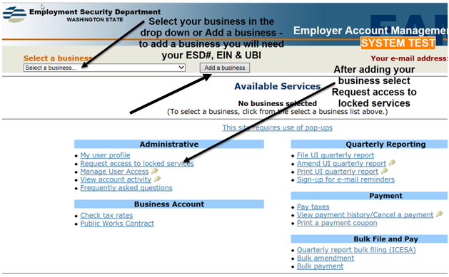
On the screen below, enter your ES Reference #, federal EIN and UBI. 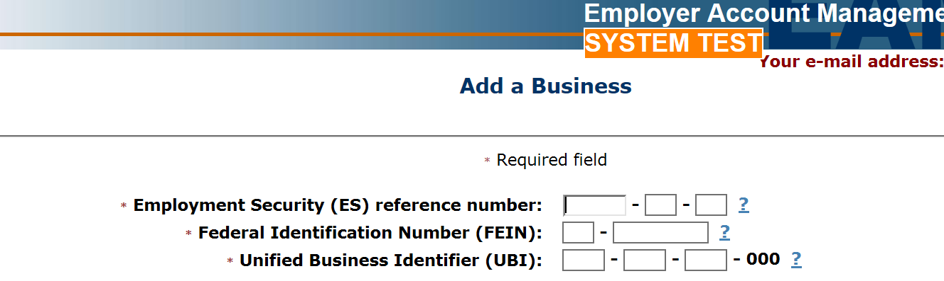

Return to the Available Services menu and select Request access to locked services. Icons that look like a key appear next to links usable only if you have access to locked services. 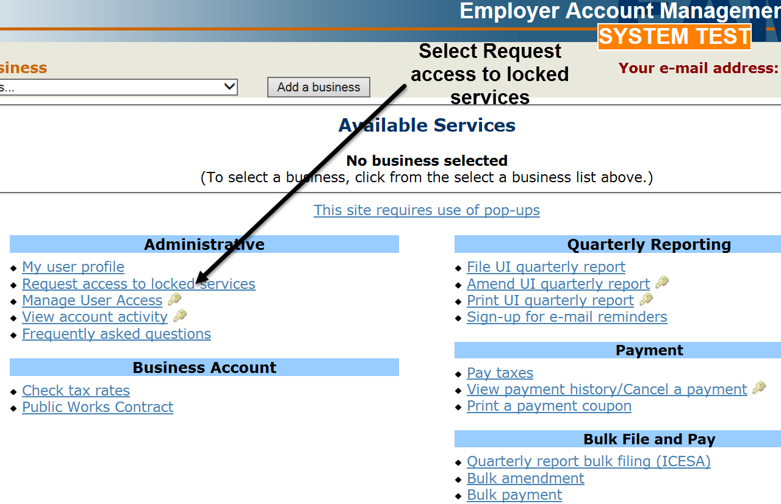
Answer the questions on the next screen. 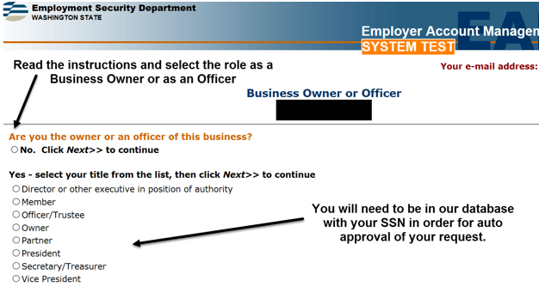

If you are an owner or corporate officer of the business listed in EAMS, we will automatically approve your access to locked services. If your name is not in our system, you will get this screen: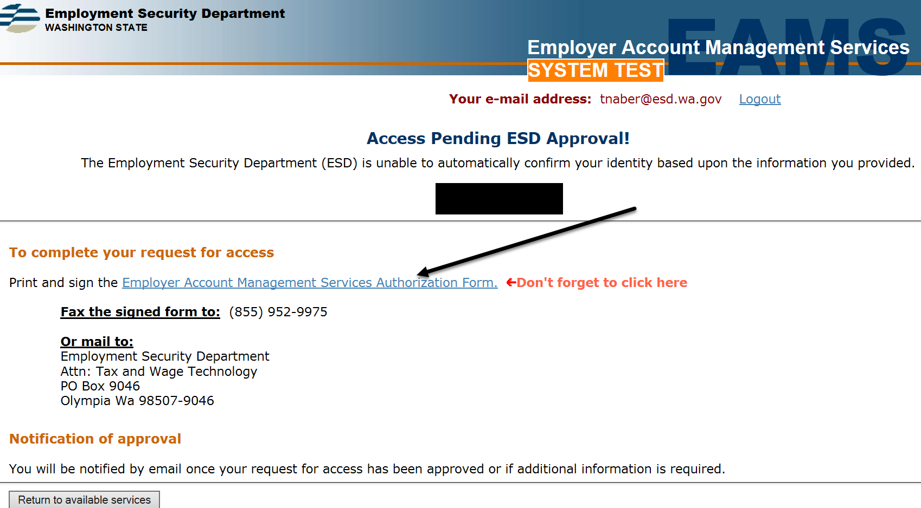
If you are automatically approved, return to the Available Services page. Key icons appear next to links usable only if you have access to locked services. 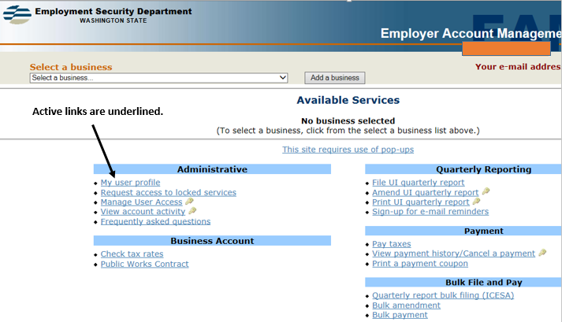
If you are not the owner or corporate officer of the business, select No and Next.
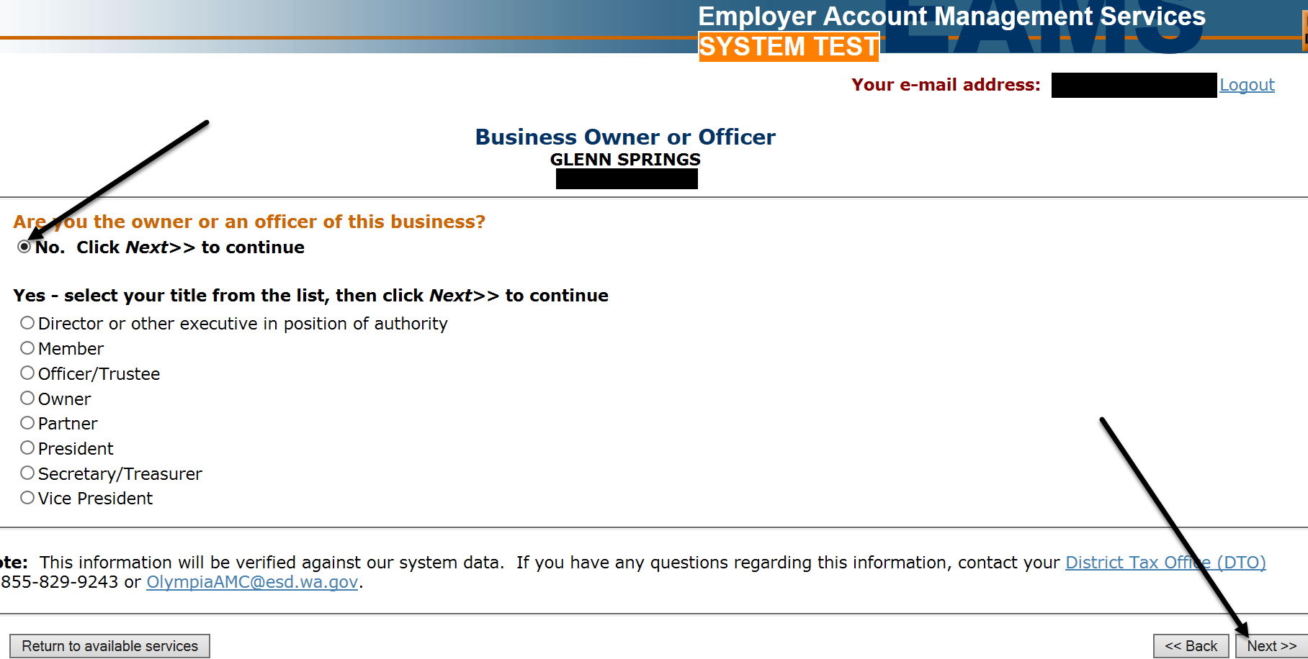

Choose whether you are an employee of the business, a 3rd party preparer or a professional tax preparer.
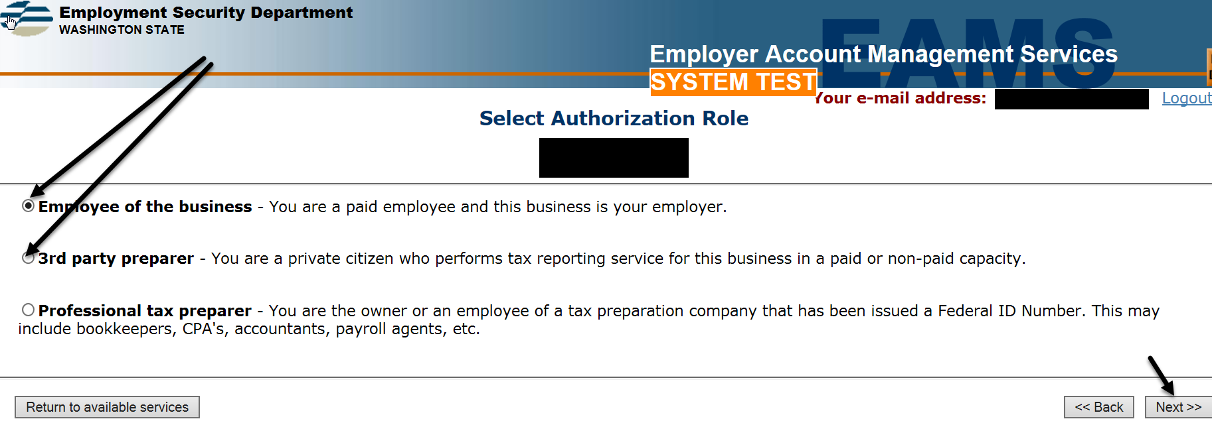

This screen will tell you what to do next.
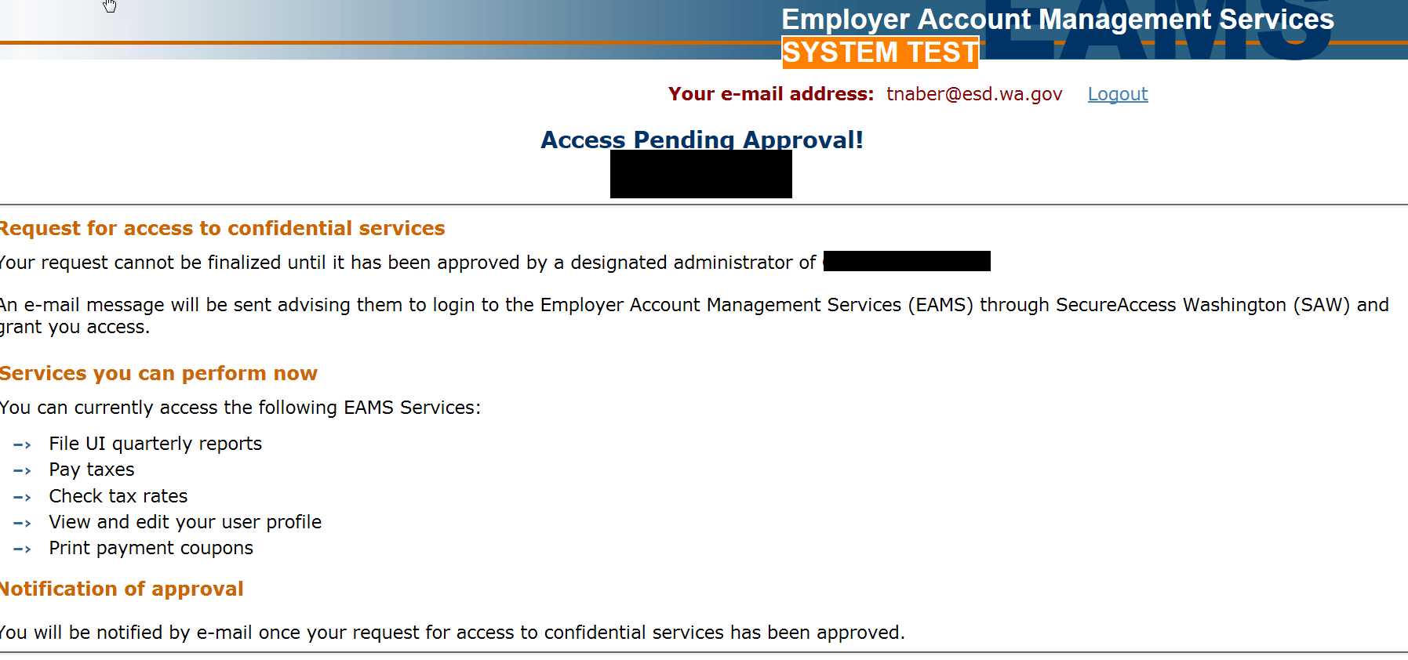

If you tell us you are a professional tax preparer and select Next…
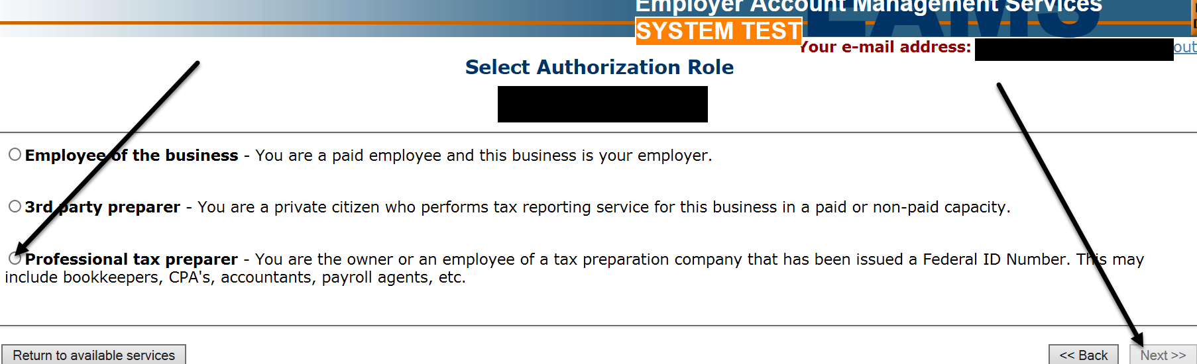

You’ll see this screen:
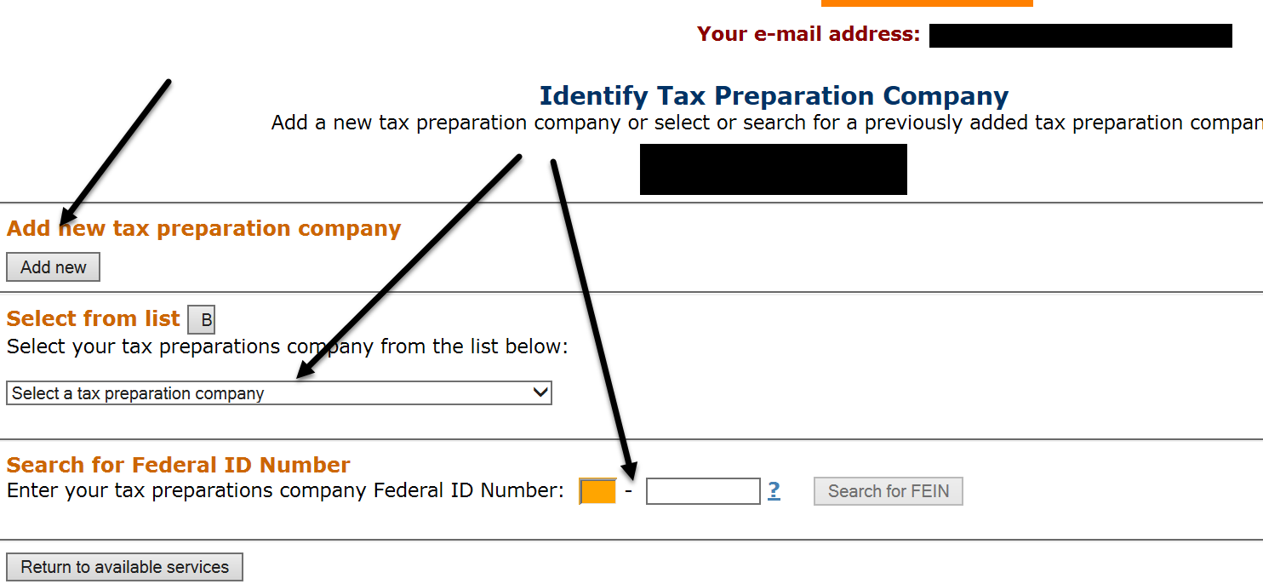

You’ll see this screen if you click Add new tax preparation company.

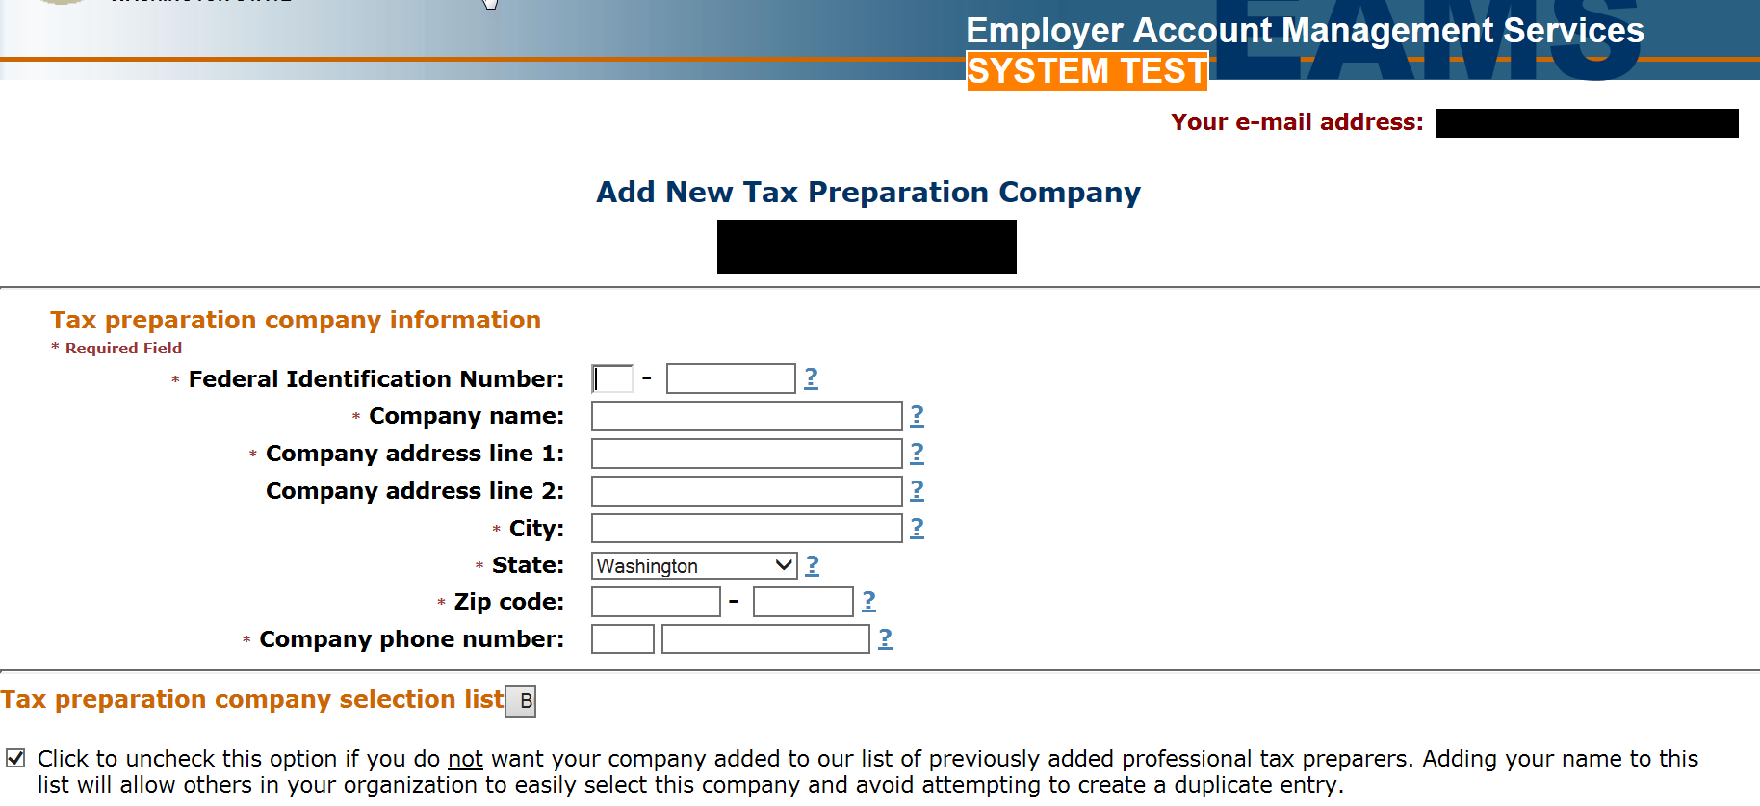

If you click Select from list, you’ll see an alphabetized list of payroll and accounting firms from which to select.
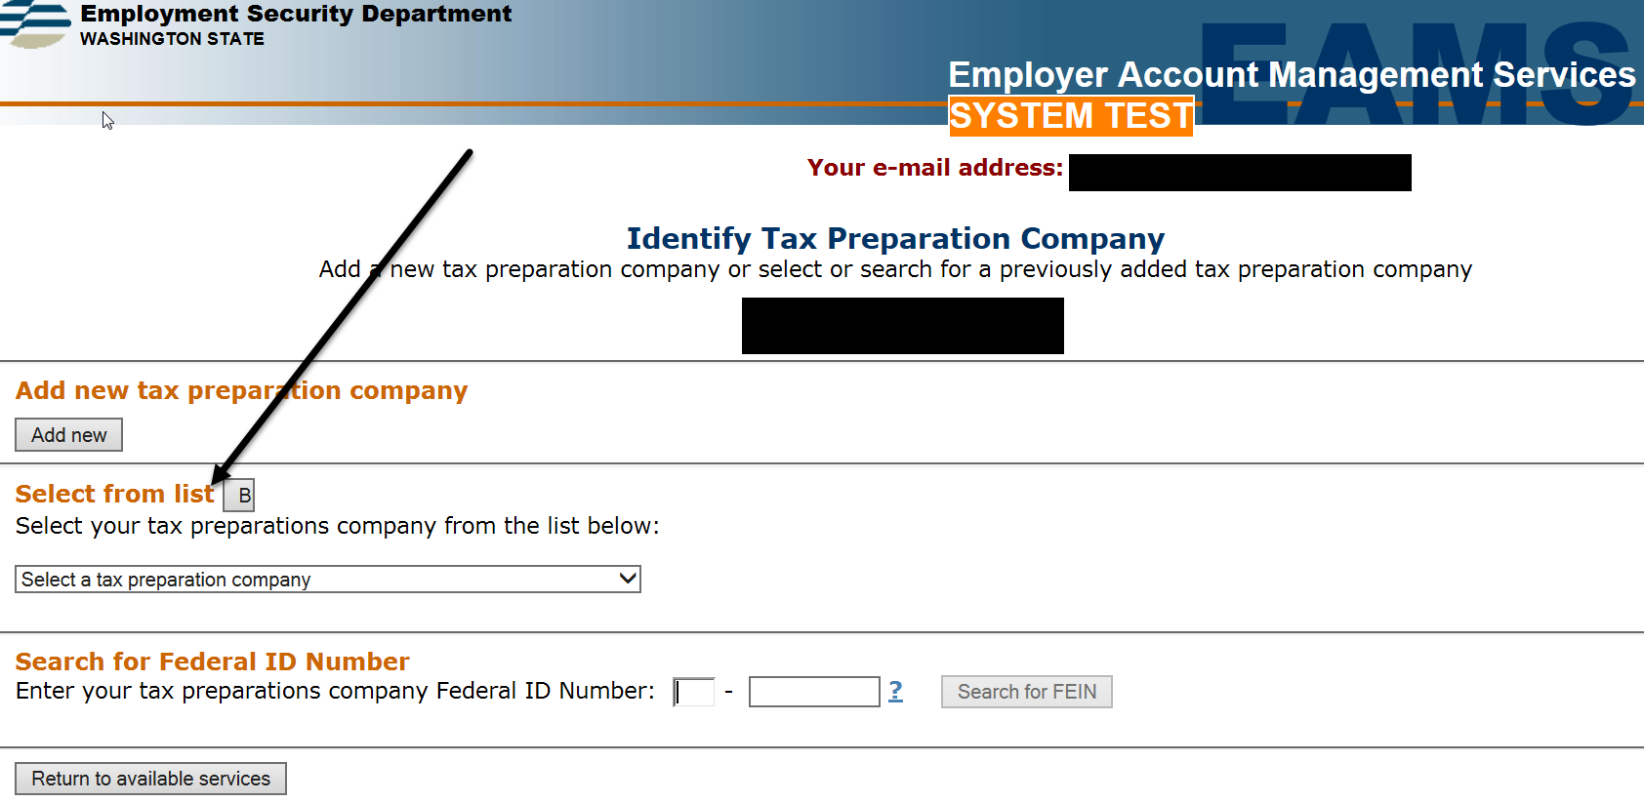

The next screen will be:
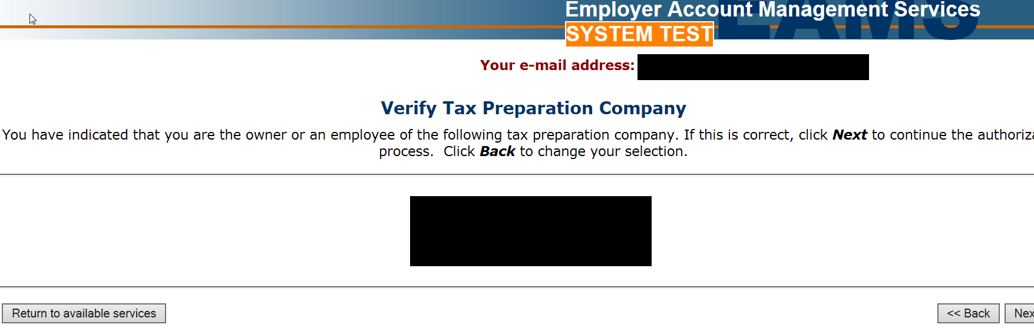

This screen will tell you what to do next. Employment Security will approve your request on behalf of the owner if the Employer Account Management System Authorization Form is completed correctly with the employer’s information and signature.
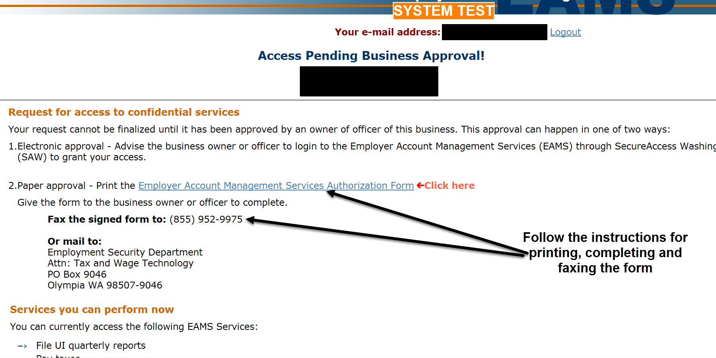

Once you have access to locked services, you’ll be able to click the links next to the key symbols.
